

**GGE6900 Research methods**

**Reading Skills Assignment**

**Part 1**

**Professor Monica Wachowicz**

**Nasrin Eshraghi Ivari**

**October 2019**

**Introduction**

* Search for the top 5 journals in your field.
* Use Scopus, Web of Science, Science Direct, and Google Scholar.
* Write down a report containing the statistics and your explanation for selecting the journals.
* Submit the document to D2L.

The five Journals which I have chosen are listed below. I have tried to find the most relevant journals to my research area which I used some technical and sensitive keywords to find the most relevant papers such as data science and big data, sensors, IoT, movement analysis and so on.

I investigated for these journals both in Scopus and web of science and then tried to find more information on google scholar. Most of this information is gathered from web of science repository.

Based on my research topic and my background, some of these journals are computer science and engineering. Most of them publish high quality, scholarly research papers that cover my research scenarios.

1. **EPJ Data Science**

Start of publishing paper year: 2015

Publisher: Spring Nature

Categories: Mathematics: Modeling and Simulation, Mathematics: Computational Mathematics, Computer Science: Computer Science Applications

2018 Journal Impact Factor: 3.26

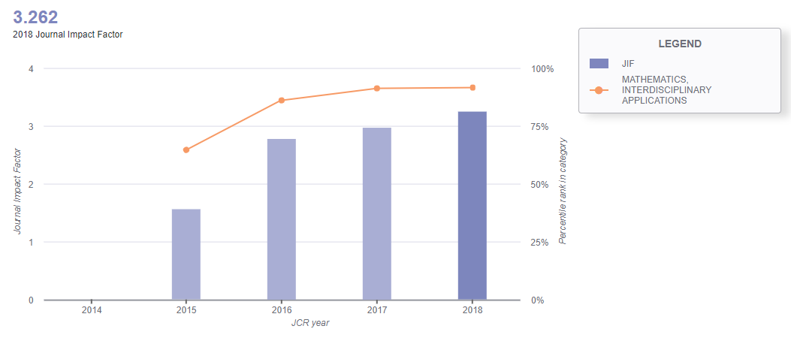

Figure 1 impact factor chart of the journal

Citation distribution 2018: 2

Total citation: 520

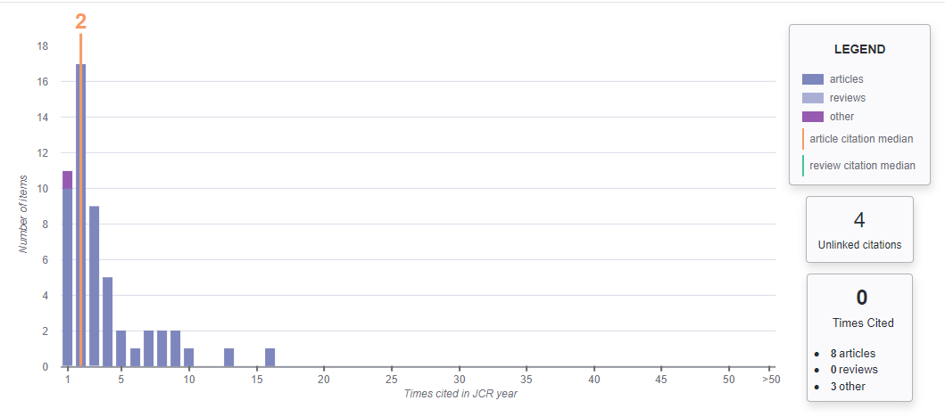

Figure 2 Citation distribution

1. **EURASIP Journal on Wireless Communications and Networking**

Start of publishing paper year: 2004

Publisher: Spring Nature

Categories: Mathematics: Computer Science: Computer Networks and Communications, Computer Science: Computer Science Applications, Computer Science: Signal Processing

2018 Journal Impact Factor: 1.59

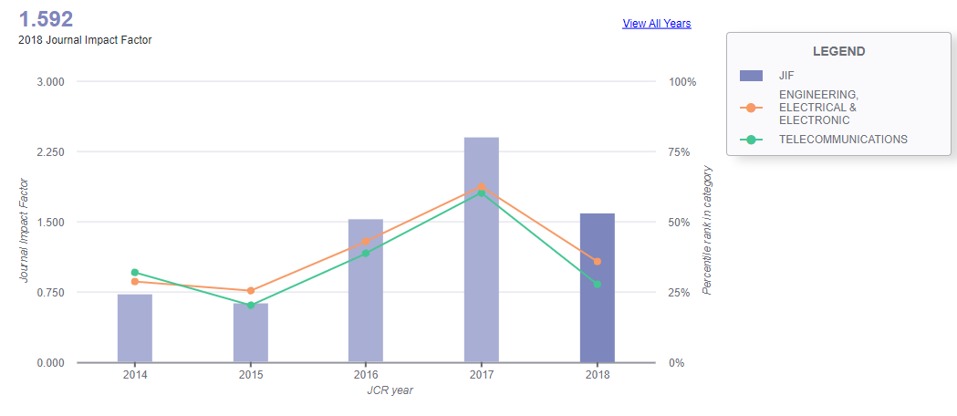

Figure 3 impact factor chart of the journal

Citation distribution 2018: 2

Total citation: 3447

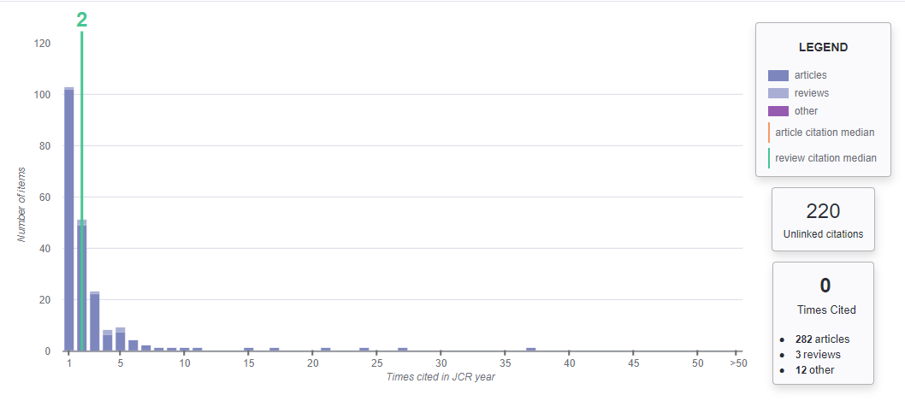

Figure 4 Citation Distribution

1. **Journal of Big Data**

Start of publishing paper year: 2014

Publisher: SpringOpen

Categories: Mathematics: data capture and storage; search, sharing, and analytics; big data technologies; data visualization; architectures for massively parallel processing; data mining tools and techniques; machine learning algorithms for big data; cloud computing platforms; distributed file systems and databases; and scalable storage systems

2018 Journal Impact Factor: 2.10

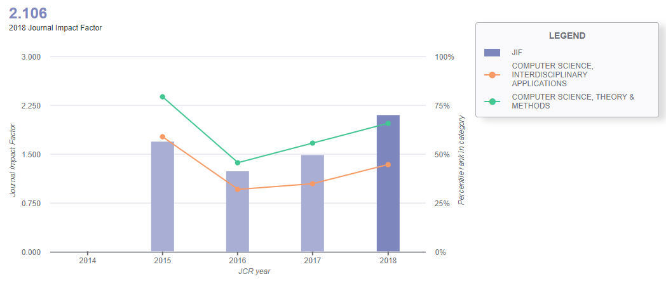

Figure 5 impact factor chart of the journal

Citation distribution 2018: 2.5

Total citation: 418

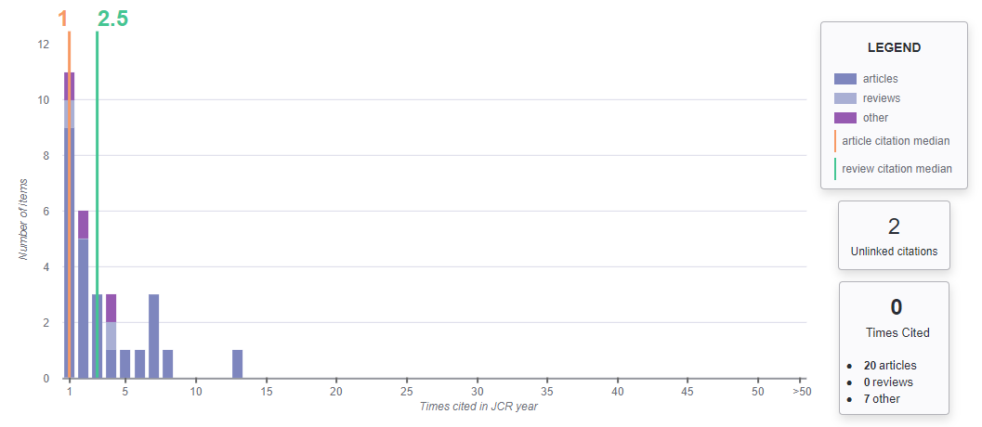

Figure 6 Citation Distribution

1. **Journal of Engineering and Applied Sciences**

Start of publishing paper year: 2008

Publisher: Medwell

Categories: General Engineering

Citation distribution 2018: 2

Total citation: 3447

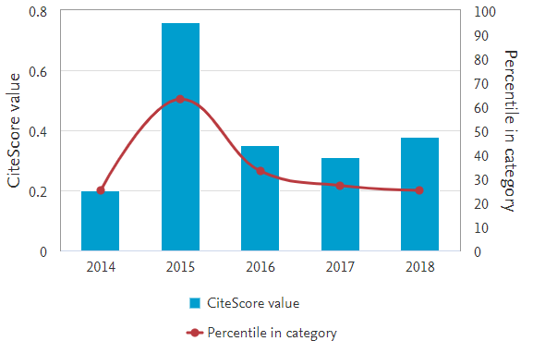

Figure 7 Citation Distribution

1. **IEEE sensors journal**

Start of publishing paper year: 2001

Publisher: IEEE

Categories: Physics and Astronomy: Instrumentation, Engineering: Electrical and Electronic Engineering

2018 Journal Impact Factor: 5.5

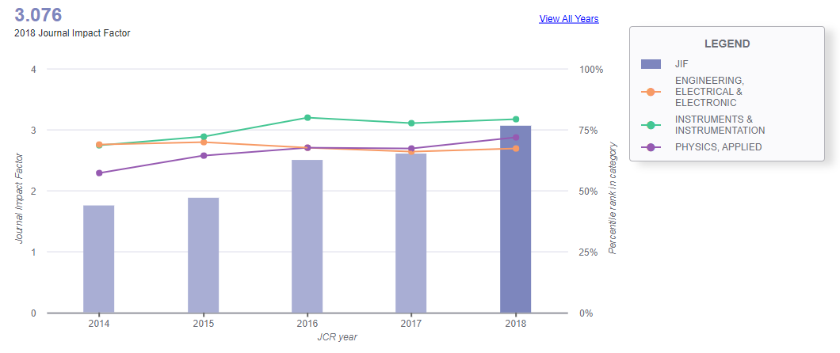

Figure 8 impact factor chart of the journal

Citation distribution 2018: 3.96

Total citation: 11244

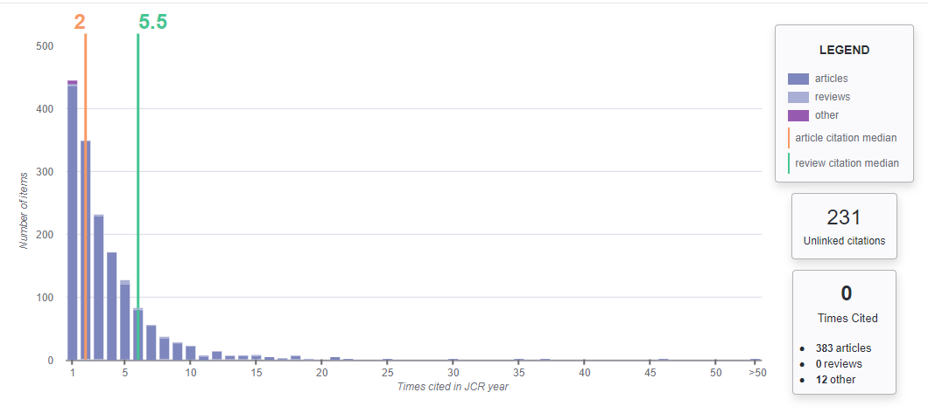

Figure 9 Citation Distribution

1. **CODATA Data Science Journal**

Start of publishing paper year: 2006

Publisher: Committee on Data for Science and Technology (CODATA) International Council for Science (ICSU)

Categories: [Computer Science Applications](https://www.scimagojr.com/journalrank.php?category=1706), [Computer Science (miscellaneous)](https://www.scimagojr.com/journalrank.php?category=1701)

H index: 17

Citation distribution 2018: 2

Total citation: 771